Term Project Deliverable #1

1. Project Proposal

I will make a Kirby side scrolling game, and I'll use Pygame to achieve this. This is not a remake. Instead, I want to create a new game but based on the characters of Kirby. According to my plan, my game will have two modes: adventure mode and protecting Kirby mode, and I'll first implement the protecting mode first. In the protecting mode, your job is to protect your Kirby, who will automatically move at the center of the screen. You can drag away the small monsters near your Kirby by using your mouse, and draw a circle around your Kirby to create a shield. In the adventure mode, you can control your Kirby freely and explore the world on your own. You can also switch to other characters by pressing different number keys instead of absorbing different little monsters to gain different kinds of power. This is just a preliminary idea, more functions and features will be added in the process of implementing the term project.

2. Technology Demonstration

I will use Pygame in my term project, and I'm pretty confident about it. Even though Pygame is relatively new to me, but I have learned this module for a while including reading various blogs and watching tutorial videos. I have already finished a little part of the project. For now, I can already control my kirby to move freely, jump and fly by using the arrow keys. I think I can handle this technology well.

3. Competitive Analysis

There are so many side scrolling games in existence, and many of them are really good, for example the original Kirby game, which is one of the best games in GameBoy. My project won't compete with them in graphics and functionalities, but the protecting mode I will add to this game is relatively new, since most side scrolling games have little interaction between the character and your mouse. But in this game, instead of playing this game solely by using your keyboard, you can also use your mouse to protect your Kirby. This might make this game more difficult to play but you will have much more fun.

4. Storyboard

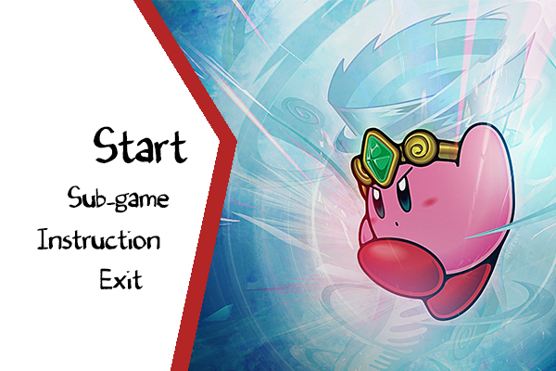

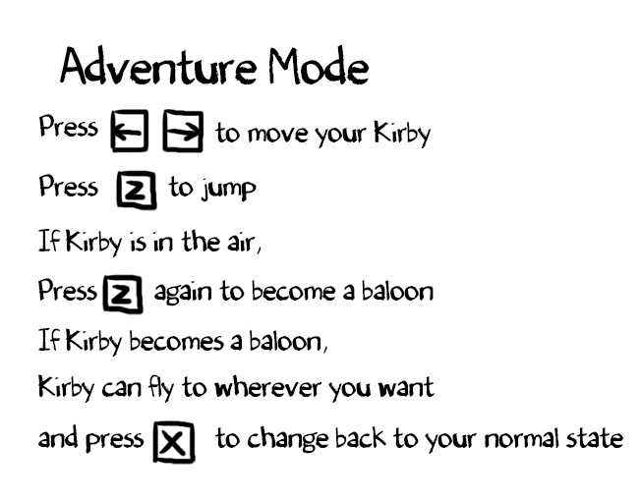

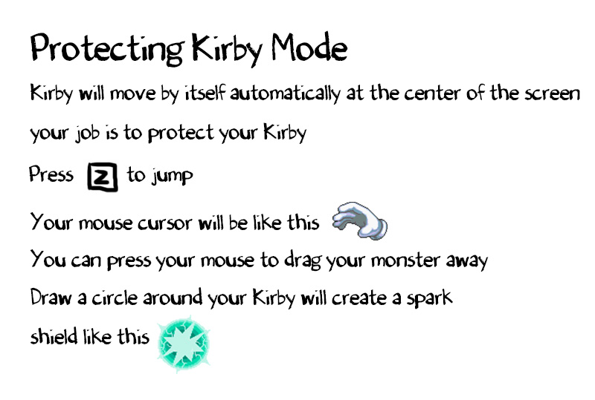

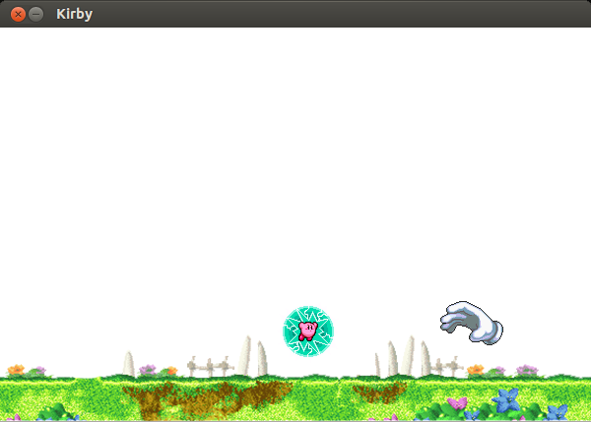

5. Code Artifacts

6. Timesheet

Before this assignment has been assigned, I spent approximately 8 hours in my term project learning pygame and writing some of the demo code.